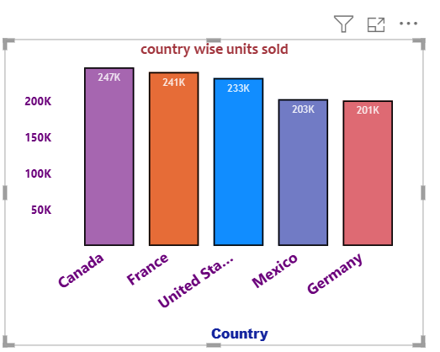

SUM OF UNITS SOLD

INSIGHTS

Step 1:go to visualization , Select: clusetred column chart ,X-AXIS = country, Y-AXIS=sum of units sold

GO TO FORMAT VISUAL

Visual= x-aixs, Font=segoeui bold , Size=16, Make it bold, Colour=#6b007b

TITLE

Title text=auto, Style=show title only, Font=arial black, Size=14, Make it bold, Colour=#12239e

RANGE

Minimum=4, Maximum=0

VALUES

Font name=segoeui bold, Size=12 ,Make it bold, Colour=#6b007b,Display units=thousands

TITLE

Tile text=auto,Style=show title only, Font=constantice ,Size=11, Colour=#e66c37

GRIDELINES

Horizontal=off

COLUMN

Categories

1 Canada

Colour=#a666b0,2 France ,Colour=#r666c37,3 USA=Colour=#118dfe,4 Mexico,Colour=#717bc5

5 Germany

Colour=#de6073

BORDER=ON

Colour=black, Width=2px

DATA LABLES=ON

Series =all

OPTIONS

Postion=inside end

VALUES

Flieds=sum of units sold, Font=Trebuhet , Size=11,bold, Colour=white,Transparency=14%

GO TO GENRAL

Title text=country wise unit sold

Heading=4

Font= Candara ,Size=16,bold,Colour=#a1343c,Horiznatal=middle alignment

Sum of units sold by country

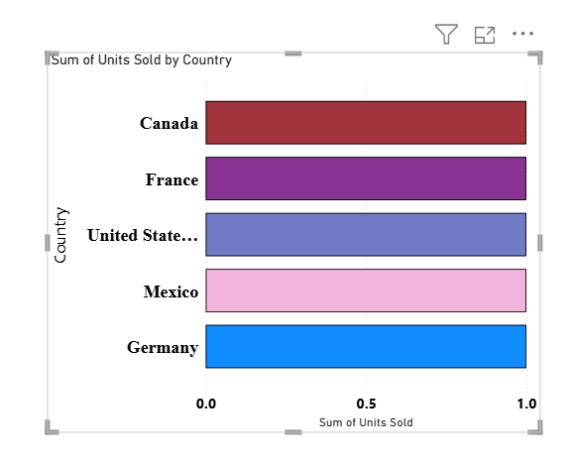

Visualization type=stacked bar chart

y-axis=country

x-axis=sum of units sold

font=times new roman, size=16,colour=black

TITLE

Font=candra,size=15,bold,colour=black

VALUES

Font-segoiue ui bold,size=12,bold,colour=black

GRIDELINES=OFF

BARS

Categories=Canada,colour=#a1343c, France=#893395 ,Usa=#717bc5 ,Mexico=#13b4dc Germany=#118dff

Border=all

Colour=black

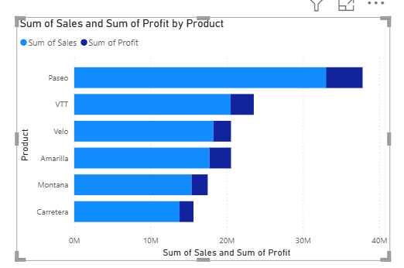

sum of sales and sum of profit by product

Insights

• Here, we are creating the visuals for sum of sales and profit by products.

• Sum of sales are represented in purple colour stacked bar chart.

• Sum of profit are represented in light orange colour stacked bar chart.

• In this visual paseo product having highest sales and highest profit compare to others product.

• Y-axis having product bar.

• X-axis having sum of sales and sum of profit.

VISUALIZATION: STACKED BAR CHART

* Y-axis=product

x-axis=sum of sales

sum of profit

* Format visual

Y-axis

Font=Georgia, Size=10,colour=black

TITLE

Font=constantia, size=14,colour=black

VALUES

Font=georiga, size=10,colour=black

GENERAL

Title

Text=sum of sales and sum of profit by product

Heading=3,canadra=14,bold,colour=black.

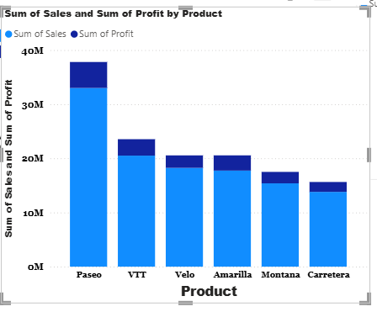

sum of sales and sum of profit by product

Insights

• Here, we are creating the visuals for sum of sales and profit by products.

• Sum of sales are represented in purple colour stacked bar chart.

• Sum of profit are represented in light orange colour stacked bar chart.

• In this visual paseo product having highest sales and highest profit compare to others product.

• x-axis having product column.

• y-axis having sum of sales and sum of profit.

VISUALIZATION:STACKED COLUMN CHART

* X-axis=product

y-axis=sum of sales

sum of profit

* Format visual

X -axis

Font=Georgia, Size=12,colour=black, bold

TITLE

Font=arial black, size=9,colour=black, bold

Y-AXIS

VALUES

Font=georiga, size=10, bold, colour=black

TITLE

Font=arial black, size=10,bold,column=black

GENERAL

TITLE

Text=sum of sales and sum of profit by product

Font=arial black,size=10,colour=black.

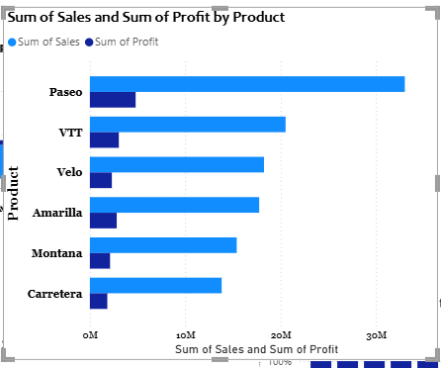

sum of sales and sum of profit by product

Insights

• Here, we are creating the visuals for sum of sales and profit by products.

• Sum of sales are represented in purple colour stacked bar chart.

• Sum of profit are represented in light orange colour stacked bar chart.

• In this visual paseo product having highest sales and highest profit compare to others product. and it was represented by millions.

• y-axis having product column.

• x-axis having sum of sales and sum of profit.

VISUALIZATION: CLUSTRED BAR CHART

* Y-axis=product

x-axis=sum of sales

sum of profit

* Format visual

Y-axis

Font= Georgia, Size=10,colour=black, bold

TITLE

Font= Georgia, size=12,colour=black, bold

X-axis

VALUES

Font=Georgia, size=9, bold, colour=black

GENERAL

TITLE

Text=sum of sales and sum of profit by product

Font=Candra ,size=10,colour=black,bold.

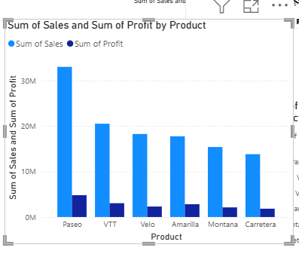

sum of sales and sum of profit by product

Insights

• Here, we are creating the visuals for sum of sales and profit by products.

• Sum of sales are represented in purple colour stacked bar chart.

• Sum of profit are represented in light orange colour stacked bar chart.

• In this visual paseo product having highest sales and highest profit compare to others product. and it was represented by millions.

• x-axis having product column.

• y-axis having sum of sales and sum of profit.

VISUALIZATION: CLUSTRED COLUMN CHART

* Y-axis=product

x-axis=sum of sales

sum of profit

* Format visual

Y-axis

Font= Georgia, Size=10,colour=black, bold

TITLE

Font= Arial black, size=12,colour=black, bold

GENERAL

TITLE

Text=sum of sales and sum of profit by product

Font=Candra ,size=10,colour=black, bold.

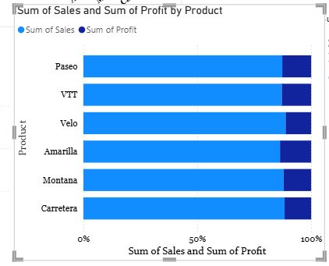

sum of sales and sum of profit by product

Insights

• Here, we are creating the visuals for sum of sales and profit by products.

• Sum of sales are represented in purple colour stacked bar chart.

• Sum of profit are represented in light orange colour stacked bar chart.

• In this visual paseo product having highest sales and highest profit compare to others product. and it was represented by millions.

• x-axis having product column.

• y-axis having sum of sales and sum of profit.

VISUALIZATION: 100% STACKED BAR CHART

* Y-axis=product

x-axis=sum of sales

sum of profit

* Format visual

Y-axis

Font= Georgia, Size=10,colour=black, bold

TITLE

Font= Arial black, size=12,colour=black, bold

GENERAL

TITLE

Text=sum of sales and sum of profit by product

Font=Candra ,size=10,colour=black, bold.

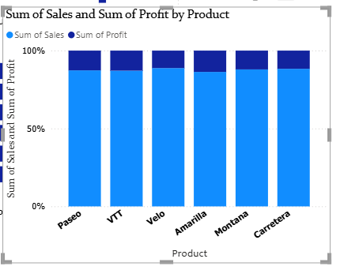

sum of sales and sum of profit by product

Insights

• Here, we are creating the visuals for sum of sales and profit by products.

• Sum of sales are represented in purple colour stacked bar chart.

• Sum of profit are represented in light orange colour stacked bar chart.

• In this visual paseo product having highest sales and highest profit compare to others product. and it was represented by millions.

• x-axis having product column.

• y-axis having sum of sales and sum of profit.

VISUALIZATION: 100% STACKED COLUMN CHART

* Y-axis=product

x-axis=sum of sales

sum of profit

X-axis

font=Tahoma, size=10,bold,colour=black

TITLE

Font=constantia, size=12,bold,colour=black

Y-axis

VALUES

Font=Tahoma, size=12,bold,colour=black

GENERAL

TITLE

Text=sum of sales and sum of profit by product

Font=Candra ,size=14,colour=black, bold.